JavaScript Assignment #1

Grading Note: Grading will be based on whether your page does what it is supposed to do, but also that it is written properly with correct HTML 5, CSS, and JavaScript. If any of your assignment parts isn’t working right but you are turning it in anyway, be sure to indicate that it doesn’t work properly. I will discover this anyway, but you might save me a lot of time and keep me in a better grading mood!

**Part 1: About Me**

Write the HTML needed to produce this screenshot, shown below, with the following guidelines in mind.

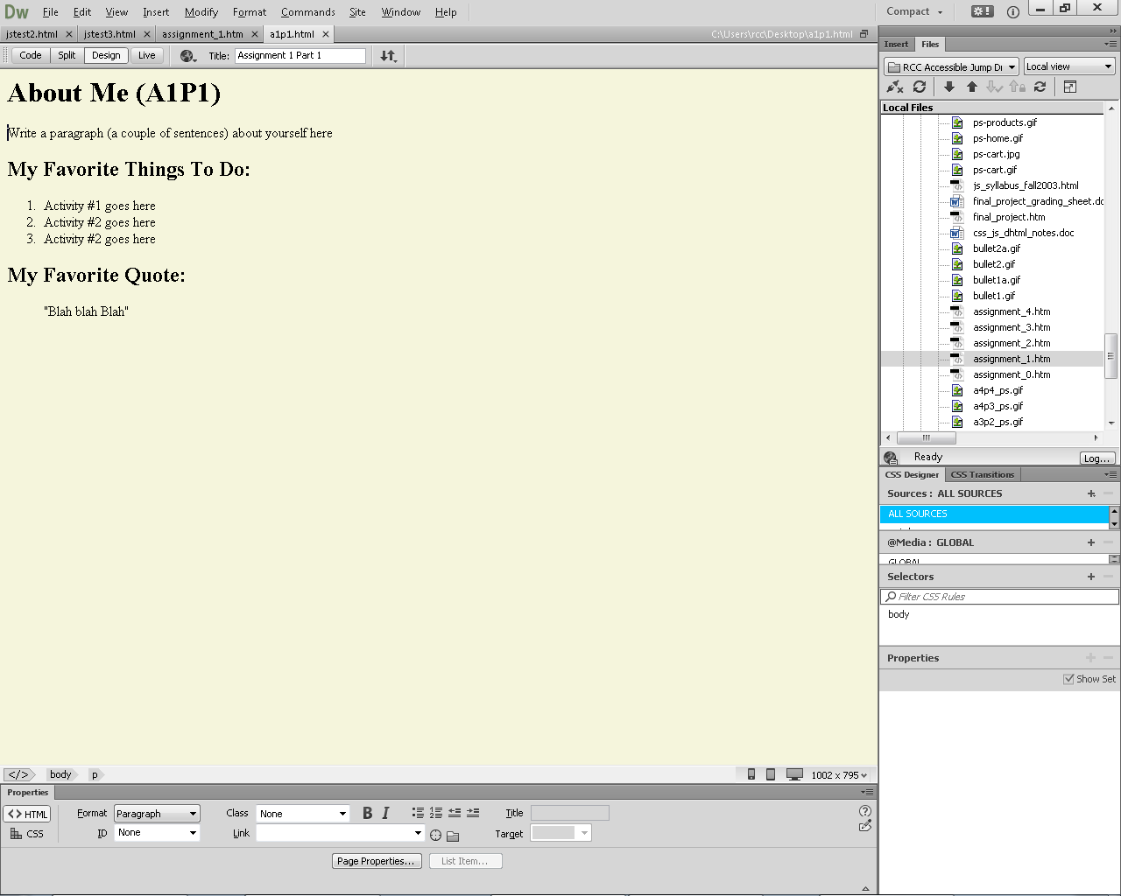

Use proper HTML 5 syntax. Your name must appear in the “title” code. Your name must appear instead of the word “Me” in the page’s main heading. Below the main page heading, write your own paragraph about yourself. Below the second heading, list 3 activities of your own that you like to do within an ordered list as shown. After the last heading, use a “blockquote” to display a quotation that you like. Put the quotation in “quotes”. Use CSS to give the page a light colored background (in the example I used “beige” but you can use something different). Save your page as “a1p1.html”.

**What to turn in :**

1. In the given assigment 1 Word File, paste a screen shot of your “About Me” page as it appears in the browser. Use Word to “crop” and shrink it down to something like the screenshot shown above.

2. Next, copy your page’s code and paste it below your screenshot in that same Word document. It should contain ALL of your page’s code.

**Part 2: About Document.Write**

Copy your part 1 page (a1p1.html) and use it as the starting point for part 2, which should be named “a1p2.html” (assignment 1 part 2). First adjust the code to say “A1P2” in the main heading. Rewrite the page using JavaScript as follows. Use “document.write” statements in a script within the “body” area to write out the identical HTML that was used for A1P1. Your document.write statements should produce the HTML needed for the “My Favorite Things To Do” heading and everything else down to and including the quote. (Leave the existing HTML intact for everything above the "My Favorite Things" heading on the page.) Finish the script off just above the existing </body> and </html> so that your script does not try to create those last 2 tags. Keep in mind that the goal is for the page to look the same in the browser as your part 1 HTML did, but those last 2 sections of the page are to be created entirely by document.write statements.

**What to turn in :**

1. Copy your page’s code and paste it where it goes in the given A1P2 area within that same Word document. It should contain ALL of your page’s code. Note that I do not need to see any screenshot for this one.

**Part 3: Temperature Conversion**

Using the formula shown on page 40 of your textbook, create a Web page that uses a prompt to ask the user what the temperature is in Celsius and then produces the equivalent temperature for Fahrenheit using "document.write" statements in a paragraph at the bottom of the page. For example, if the user types in **10** to the prompt, the last paragraph of your page should read “10 degrees Celsius is equal to 50 degrees Fahrenheit!” Begin by creating the necessary HTML 5 page structure to support this page. One way to do so would be to just copy the A1P1 page and remove some of the no longer needed activities and quote. You must have an “h1” heading at the top of the page identifying it as “A1P3 Temperature Converter” and a paragraph below it that displays the proper formula for converting temperatures – so that the user knows how you are doing your calculations.

**What to turn in :**

1. In the given assignment 1 Word File, paste a screen shot of your “A1P3” page as it appears in the browser **after** entering a temperature. Use Word to “crop” and shrink it down to a reasonable size, as needed.

2. Next, copy your page’s code and paste it below your screenshot in that same Word document. It should contain ALL of your page’s code.

**Part 4: Alert -- It’s Freezing in Here!**

Copy your A1P3 temperature page and add the following functionality to it. Use “**if**” statements to determine whether the Fahrenheit temperature you calculated is at or below freezing (32 degrees or below.) If it is, you should add the message “And that is freezing cold!”. (See the example screen shot below.) This message should be produced with “window.**alert**” (see sample screen shot below). Put the “freezing message” at the end of the previous temperature message so they are displayed together as shown in the sample screenshot. Save this page as “a1p4.html” and adjust the main heading and title to reflect this is A1P4 (as needed).

**What to turn in:**

1. Copy your page’s code and paste it where it goes in the given A1P4 area within that same Word document. It should contain ALL of your page’s code. Note that I do not need to see any screenshot for this one.

Although you do NOT have to turn in a screen shot, here is what it might look like when it is working correctly:

